MIDDLE SCHOOL
Biotechnology

Crossing Hairs

Teacher Background:
There are, essentially, 3 ways that an organism can be modified. 1) natural selection over time, 2) cross-breeding and hybrids, and 3) genetic modification. Yesterday, students experienced a simulation for how natural selection works; today, the lesson will focus on cross-breeding and hybrids, putting students in the position of a breeder of cats.

Goal: Students will consider desired traits for cats and determine how a breeder might combine different breeds to achieve those traits.

Objectives: Students will…
- Evaluate traits of different breeds
- Rationalize breeding decisions to achieve desired traits
- Review punnet squares to evaluate probability of achieving desired traits in offspring
- View results of bacteria lab
- Discuss potential medical implications for genetic modifications in the future

Materials:
- Gallery Cat color pictures and information about cat breeds
- Starter Cat Color pictures and information for student groups
- Overhead of Crossing Hairs Game Rules
- Overhead of Crossing Hairs Example
- Overhead transparency of scenarios

Time Required: 60 minute class period

Standards Met:
- Life Science Standards: Diversity & adaptations of organisms

Procedure:
Prep:
- Hang “Gallery Cat” pictures and information around the room
In Class:
- Review the 3 ways that an organism can be modified. 1) natural selection over time, 2) cross-breeding and hybrids, and 3) genetic modification.
- Share with students:

  - Breeding: Dogs who are considered to have desirable traits are mated to produce puppies. For example, a Labrador retriever is considered to be a sought-after breed because it is generally intelligent, athletic, friendly, and able to be calm in a house. The poodle does not shed frequently. The two are mated for puppies that, hopefully, have the best traits from each breed. This is how current Labradoodles are created.
- Tell students that today they will focus on cross-breeding cats.
- They are now professional breeders.
  - Clients will come to them with specific traits they would like in a cat
  - Students determine which 2 cats to breed to create those traits
- Have students work in groups of 2 or 3
- Put up example. Explain Starter Cats and Gallery Cats.
- Put up Crossing Hairs Game Rules
- Overview the “Gallery Cats” pictures and information hanging around the room
- Give each pair one “Starter Cat” picture and information
- Explain to students that each group will have to determine which “Gallery Cat” to breed with their “Starter Cat” to get the desired traits
  - Remind students that cross-breeding is an option, but they can also choose to create a pure breed by standing by that sign
- Place first scenario on the overhead and allow students to stand by the Gallery Cat with whom they would breed their Starter Cat
- Eliminate students who are by a cat without the desired trait
- Ask random students to explain why they are standing where they’re standing
- At the end of the lesson, ask students to consider breeding Sparky. Would they choose to breed her with Lucky? Why or why not?
  - How would you feel if your parents chose the “best” mate for you? (like an arranged marriage)

Crossing Hairs: Scenarios

Starter Cat =
“Colorado Mini-Lynx” (this is NOT a real breed!). :
  - Large
  - Active – will go on walks and hikes with owners
  - Extremely long and heavy coat to survive Colorado winters

A highly active couple from Florida wants a cat to hike and interact with them. They need a cat who is active, large enough to survive outdoors, and with a coat for warmer weather.

Which Gallery Cat do you breed with? Why?

Based on your punnet square activity (from Sparky and Lucky’s kittens), what is the probability that the kittens will have the desired trait?

Crossing Hairs: Game Rules

- Read and listen to scenario on overhead
- Stand by Gallery Cat that you feel is the best choice for breeding the desired traits
- Be prepared to explain your choice

*double elimination – You must sit down if you are:

- Standing by a Gallery Cat which would not produce the desired trait

- Unable to give a reasonable and precise explanation how the breeding would give the desired trait(s)
Crossing Hairs: Scenarios

The president wants a cat at the White House, but his child is allergic to cats.

Grandma Baker needs companionship and is not physically up to the task of walking and grooming. She would like an indoor cat, but is afraid that kitty might break her knick-knacks.

Uncle Furby just moved into a new home and has realized that there are mice everywhere! He would like a cat, not for the companionship, but to take care of the mice. This cat will have to be comfortable with the outdoors.

The Brady Bunch, a family of 6 kids and 2 parents, would like to add a cat to their clan. They currently have 2 dogs, 3 cats, and a hamster.

Ms. Crabapple is a middle school teacher with a particularly rowdy group of students this year. She would like to get a cat, but she wants to come home to peace and quiet.

The Snottysnottertons are looking for a cat that is better than the neighbor’s pet. It needs to be unique in its looks and have a reputation for being the best.

The Maine Coon Cat
- The ‘gentle giants’ of the cat world
- They have a playful, easygoing temperament
- Loyal cats who follow their humans from room to room
- They are highly intelligent and learn quickly
- They are very talkative
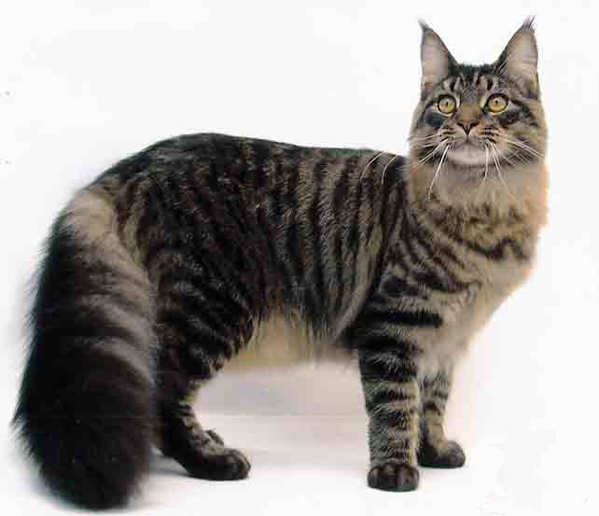
- Get along well with children and other pets- even dogs

Bengal Cat
- Good hunters
- Not lap cats; don’t like to be held
- Must be played with gently or can grow up to be rough
- They are talkative at feeding time
- Have difficulty accepting another cat
- Possibly less likely to provoke allergic reactions for people with mild allergies

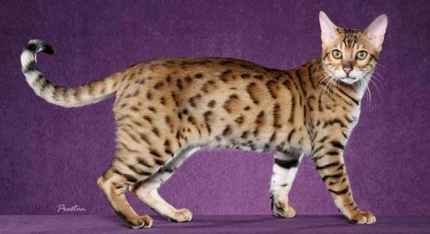
Scottish Fold Cat
- If both parents carry the "fold" gene and the kittens receive two copies of it, they will be at risk for genetic defects that can result in lameness and other problems. For this reason, two Scottish fold cats should not be bred together.
- Laid back
- Not as interactive as other breeds
- Quiet
- Get along with other pets
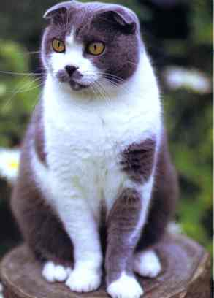
- Available in long and short hair

Sphynx Cat
- Not actually hairless, has short, downy hair
- Above average physical strength
- Sociable and affectionate, but do not like to be picked up & held
- Need a warm climate & should kept inside – susceptible to sunburns
- Get along well with other pets, even dogs
- Thought to be hypo-allergenic but some people experience worse allergic reaction, so people should test
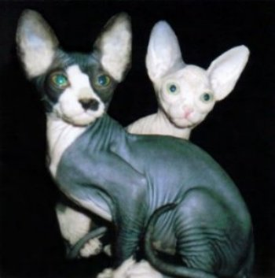

Abyssinian
- Loyal & people-oriented, charm those who don’t consider themselves cat people
- Highly active & need plenty of exercise
- Fragile objects should not be left on shelves because the cat is likely to cruise through
- Quick to purr
- Not a lap cat – dislike being restrained
- Good with dogs and older children
- Shouldn’t be left alone for long periods of time

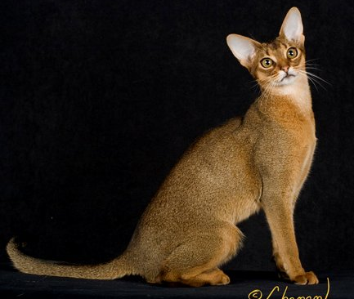
Persian
- Loving and laid back
- Mellow and not highly active
- Enjoy cuddling and getting attention
- Quiet
- Should be kept indoors

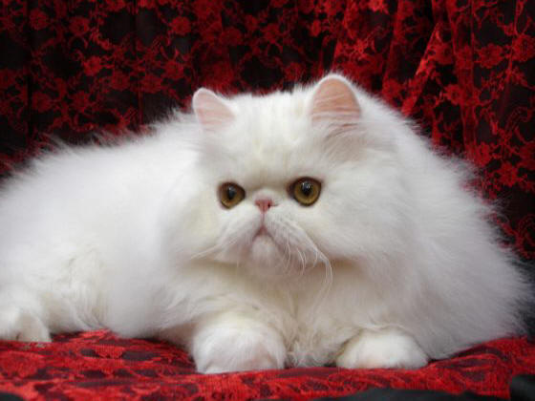
Manx
- Affectionate
- Like to sit on your lap
- Get along with other pets in a household
- Should not be left alone for long periods of time
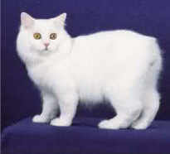
- Moderately active

Snowshoe
- Extremely intelligent, can open cabinet doors!
- Even-tempered, laid back
- Active, like to play & carry toys in their mouths
- Love attention & lap cats
- Will paw you to get attention
- Should not be left alone for long periods of time
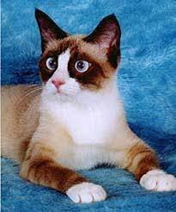
- Not loud, but very vocal

American Shorthairs
- Affectionate and sociable
- Independent and not a lap cat
- Active
- Good hunters
- Get along with children, dogs and other cats when introduced properly
- Quiet

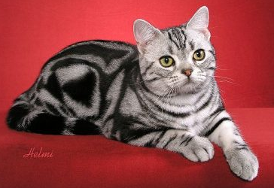
Russian Blue
- Short, dense fur
- Quiet
- Affectionate
- Very intelligent – able to open doors
- Get along with children and other pets

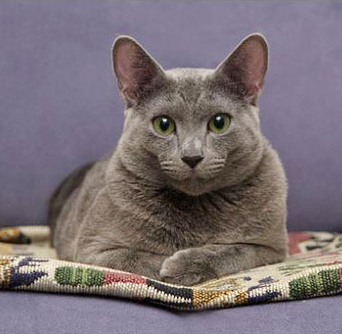
Siamese
- Short, close lying fur
- Extremely vocal and loud
- Affectionate
- Likes attention and will sit on your lap
- Intelligent

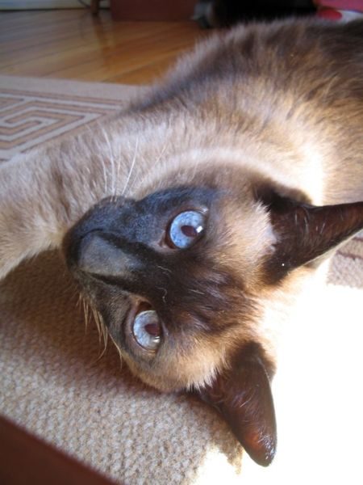
Siberian
- Semi-long hair
- Very rare breed
- Affectionate
- Loyal – follow humans around the house
- Extremely agile
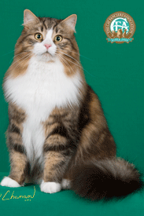
- May break fragile knick-knacks left on a shelf

RagaMuffin
- Large cat
- Strong & healthy with no known genetic problems
- Extremely sweet & laid back
- Thrives on attention – likes to be in a lap
- Get along with small children
- Loyal – follow humans around the house
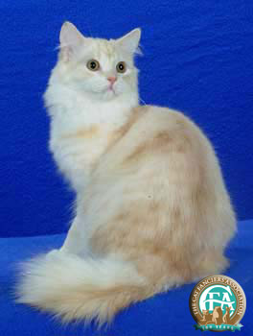
- Like to play

CASE STUDY: CATS

"Hypoallergenic" Cats For Sale, U.S. Firm Announces
<< Back to Page 1 Page 2 of 2
Costly Kitties
Approximately 10 million people in the U.S. are allergic to cats, according to the nonprofit Asthma and Allergy Foundation of America (related feature: "Allergies: A Modern Epidemic" in National Geographic magazine).
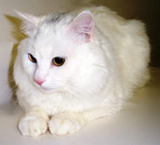
Cat allergens can trigger severe asthma attacks for 20 to 30 percent of asthma sufferers and exposure can lead to chronic asthma.
Contrary to popular belief, people are not allergic to a cat's fur or dander. The sneezing, wheezing, and itching are brought on by Fel d 1, a protein excreted in feline saliva and skin glands.
Even a hairless breed can trigger an allergic reaction. Cats—notorious self-groomers—transfer the allergy-inducing protein to their skin and fur while licking themselves.
According to Young, Allerca researchers used genetic sequencing to search for natural variations in the genetic code of the Fel d 1 protein.
They then selectively bred cats to express the protein at a lower molecular weight, reducing the likelihood of an allergic reaction.
Allerca's low-allergen felines, expected to arrive in homes next spring, carry a price tag that could send some pet lovers into shock. The firm currently charges $3,950 (U.S.) per cat, plus nearly $1,000 for processing and transportation.
The steep cost includes pet insurance, vaccines, a microchip identifier, spaying or neutering, nail caps, and a starter kit. Kittens will be delivered via private jet courier to pre-selected veterinary offices where owners can pick them up.
Because building up a breeding pool takes time, Young projects that Allerca will only have 400 to 500 cats available next year.
As a safety precaution, Young says the kittens will be tested for their Fel d 1 levels before they are delivered. Owners and their homes must also undergo FDA-approved allergy tests to create a baseline for any preexisting allergens.
Should an individual exceed the threshold level for tolerating the new cats' low levels of allergens, Allerca will strongly suggest the owner not claim the cat and will refund the purchase price.
Cat Fight?
A Denver, Colorado-based firm, Felix Pets, is trying to produce hypoallergenic cats using a different technique: developing a hypoallergenic cat via direct cellular modification.
In theory, while a developing kitten is still a single cell, its DNA can be modified to remove or suppress the gene that produces the allergen protein, Felix Pets' president David Avner explains.
The modified cell would then be implanted into a surrogate mother cat to finish developing into an allergen-free kitten.
Avner says gene modification has an advantage over selective breeding in that modification takes less time to produce a cat consistently free of the allergen protein.
"To breed out the allergen could take decades," he said.
Avner says he expects to have transgenic allergen-free cats ready for the market by 2008. While kittens will be "expensive" initially, Avner said, he hopes to eventually sell them for $800 to $1,000.
Felix Pets is a division of New York-based Transgenic Pets, which brought a lawsuit against Allerca over intellectual property issues in 2004. That suit was settled out of court for an undisclosed sum in 2005.
According to Young, Allerca had been pursuing genetic modification until last year, when researchers ran into challenges silencing the allergen-producing gene.
But it was during this research that Allerca developed genetic testing to focus on less potent versions of the Fel d 1 protein.
Little is known about the exact role the Fel d 1 protein plays in cats, so no one is sure what effect removing or suppressing the protein would have on an animal.
Duane Kraemer is a professor of veterinary physiology and pharmacology at Texas A&M University in College Station, and the owner of "CC," the world's first cloned cat (related news: "Cat Cloning Offered to Pet Owners").
"The only way to determine that would be to do some of the knockout experiments and see how the cats do," Kraemer said, referring to clinical trials in which a target protein is "knocked out" of an animal's genetic code.
UC Davis' Lyons, agrees: "If [we learn] anything from these experiments these companies are doing, we might learn a lot about the physiology of this particular protein."

Article from: http://news.nationalgeographic.com/news/2006/06/060609-allergies-cats_2.html

