
MIDDLE SCHOOL
Math & Engineering

Final Budget

Goals: To apply math skills to a real life budgeting situation

Objectives: Students will…..
- Determine actual costs of materials using Construction Estimating List for House Building from Part I
- Calculate 7% sales tax on each item to be purchased (windows, doors, foundation, etc.) and round to the nearest cent
- Calculate amount of loan spent using a transaction register
Standards met:
Connections:
- Recognize and apply mathematics in contexts outside of mathematics
Numbers & Operations:
- Work flexibly with fractions, decimals, and percents to solve problems
- Select appropriate methods and tools for computing with fractions and decimals, and apply the selected methods

Time required: 2 class periods

Materials: (for 30)
- 30 copies of Transaction Register
- 30 copies of Vendor List
- 2 sets of front-to-back checks per student
- Overhead transparency of the transaction register
- Overhead transparency of checks
- Individual copies of student completed “Construction Estimating List for House Building”
- 30 copies of vendor’s list
Prep:
- Make copies of the transaction register and checks
- Optional: ask a local bank to donate check books to the school so students have the opportunity to use actual checkbooks
Procedure:
- Give each student a copy of the transaction register
- Using overhead, have a student place the loan amount in the correct place on the balance sheet
- Students should add the loan amount to his or her transaction register
- Review methods of rounding, finding percents and decimal computation
- Ask students to use their “Construction Estimating List for House Building” from Part I to calculate the cost of materials plus 7% for every purchase on the list and round to the nearest cent
- Using the vendor list, transaction register and the checks, student will write a check to each company for materials and balance the amount on the balance sheet using decimal computation until all vendors are paid
- Model the first transaction using the overhead transparency of the balance sheet and check
Assessment:
- Transaction Register

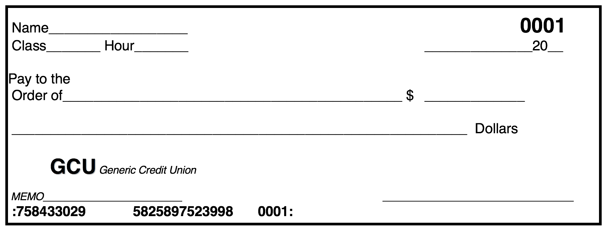

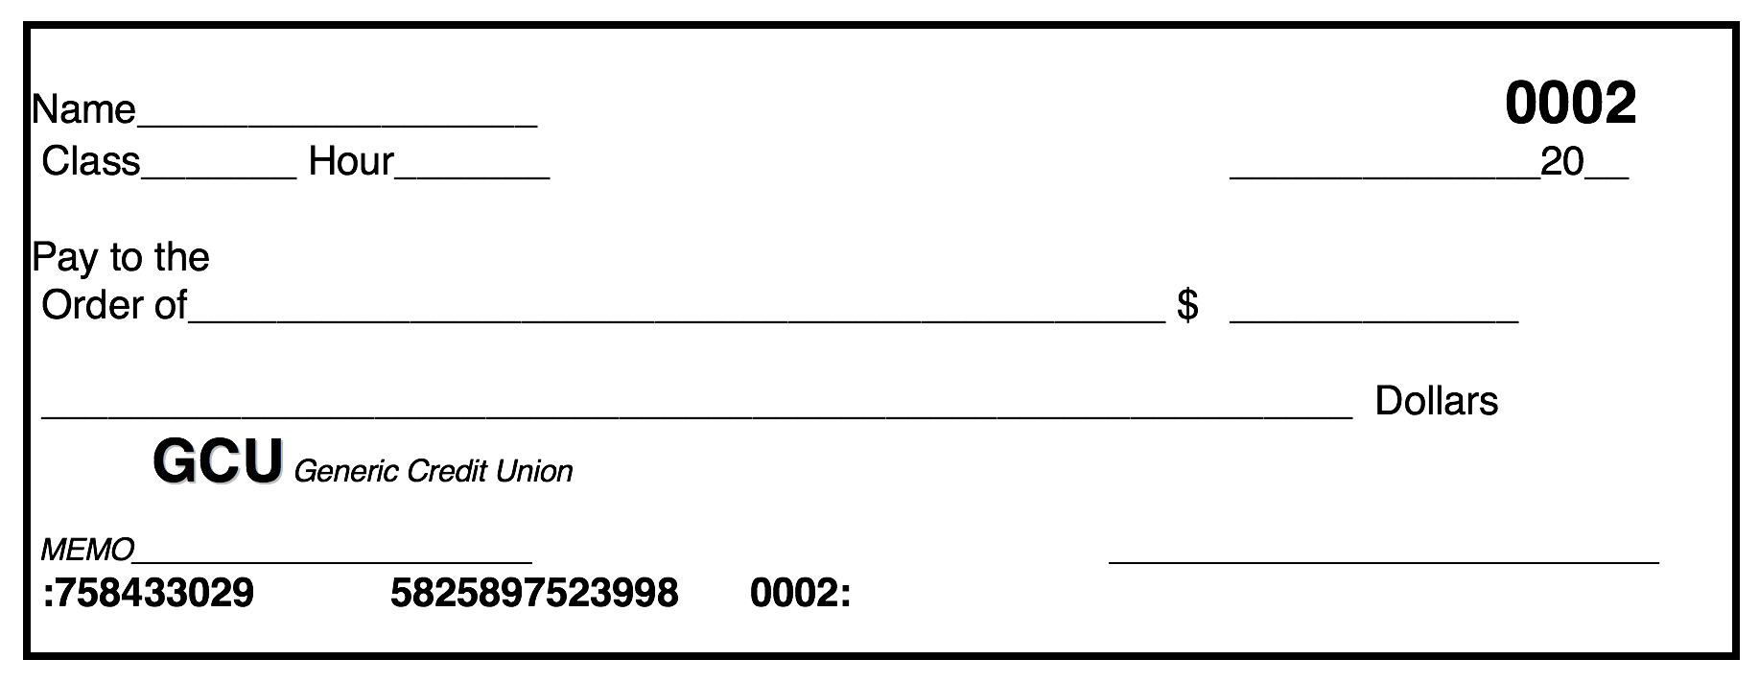

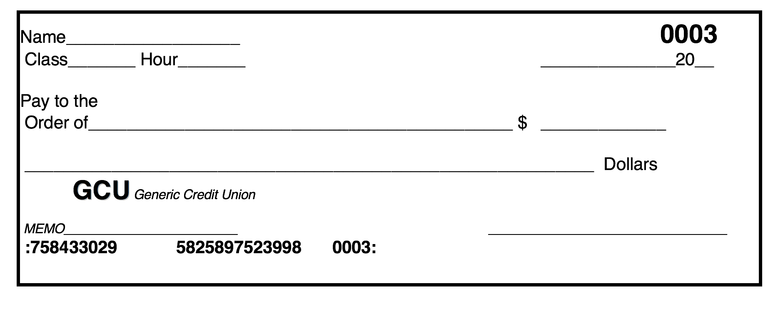

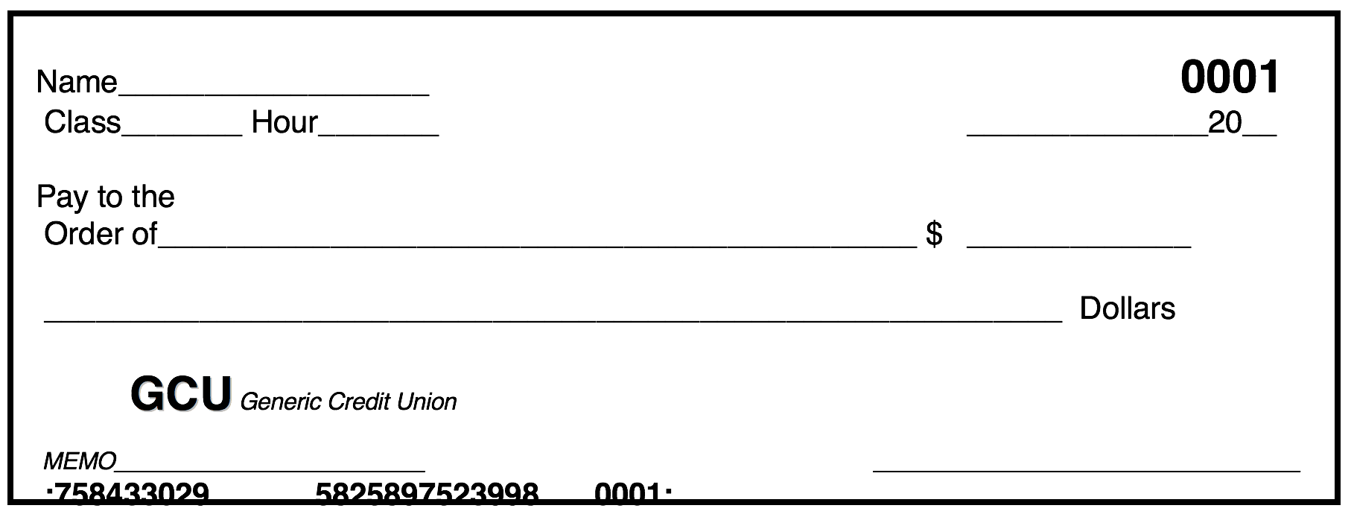
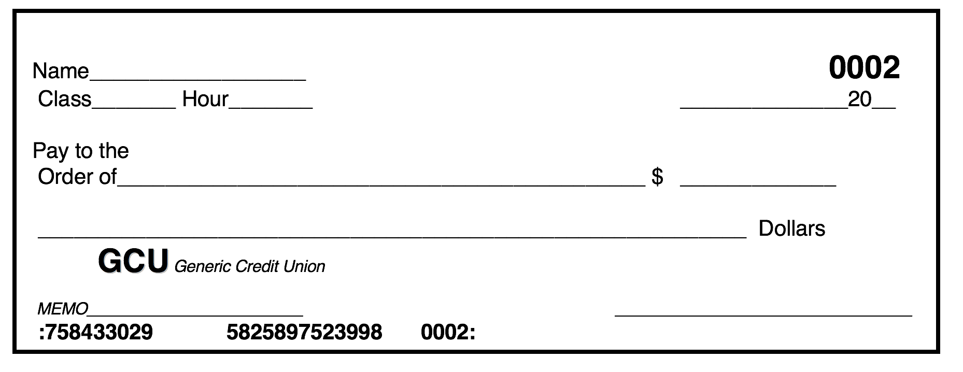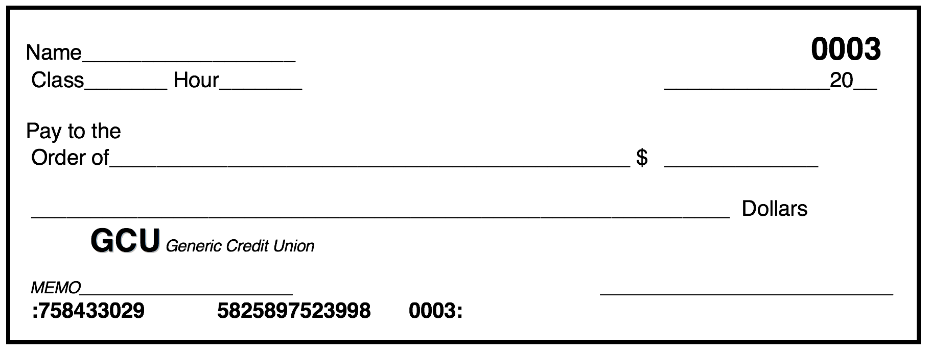
Final Budget: Transaction Register

CHECK # | DATE |  | TRANSACTION DESCRIPTION |  | Subtractions (-) | Additions (+) | Balance (=)
Final Budget: Vendor List

Foundation: Zippy’s Foundations, LLC

Water, electric
& gas: City Utilities
Walls: Humpty
Dumpty
Construction Co.

Roof: Reindeer Roofing

Interior Doors: Slammin’ Doors

Exterior Doors: No Draft Doors Inc.
Windows: Ike & Cee Glass

Heating & Cooling: Fire and Ice Plumbing

