MIDDLE SCHOOL
Biotechnology

Great Expectations Through Modifications

Teacher Background:
There are, essentially, 3 ways that an organism can be modified: 1) natural selection over time, 2) cross-breeding and hybrids, and 3) genetic modification.

Goal: To understand the process of genetically modifying an organism as they learn how insulin is formed. To understand that many inventions/medications that sounded impossible years ago have already been developed. What does the future hold?

Objectives: Students will…
- Analyze an episode of The Jetsons and pictures of technology changes to conclude that many aspects once thought of as futuristic are now commonplace.
- Look at results from yesterday’s lab and discuss what happened.
- Discover the cause/symptoms of diabetes (optional)
- Sequence the discovery of insulin
- Discover the steps of Recombinant DNA in insulin production
- Create a poster showing the steps of Recombinant DNA

Materials:
- Computer access to view The Jetsons and 2 youtube videos
- Projection system
- Great Expectations Through Modifications overhead of boom boxes, early computers, original cell phone
- T chart on the board or on easel paper
- Agar plates from Real Cats Wear Pink lab activity
- Copies of the Insulin timeline
- Materials for poster making
- Poster board,
- Various artistic supplies: pipe-cleaners, glue, construction paper, straws, macaroni clay, markers

Time Required: 2 60 minute class periods
(poster production may take longer)

Standards Met:
- Science and Technology Standards: Understanding about science & technology
- History and Nature of Science: Science as a human endeavor


Procedure:
Day 1
- Ask students if they have ever watched The Jetsons television show. If some have, ask them to share with their knowledge with the class. Inform the class that Jetsons was a cartoon created in the early 1960s, that was futuristic. At its time of creation, all of the ideas were unheard of.
- Watch the following short video: “ The Jetsons Future of Technology”
https://www.youtube.com/watch?v=e8SC6bny1SA&list=PLqisZr34AmZIgG7SgdrotlWL8P8igHPj0
- As the students watch the video, they create a list of ideas/objects that they see in the show that are now part of our daily lives and a list of ideas/objects that are still not reality.
- Draw a t-chart on easel paper or on the board and ask students for items on the lists. What do we have now and what is still not a reality from the show?
- Discuss why some objects were invented and why some still have not been invented.
- Show the Great Expectations Through Modifications overhead.
- Ask the students to look at the pictures and decide what objects are now used. How have these inventions changed over time? Have the inventions changed for the better? Why?
- Read the questions on the bottom of the overhead and discuss answers.
- Remind the students that they were hoping to see some changes with their “bacteria plate” from Real Cats Wear Pink (lesson 1). What did they predict they would see?
- Each group receives their agar plate and observes the changes.
- Discuss these changes. What caused the bacteria in the agar plate to turn pink? Mention that this is genetic modification because the bacteria were changed due to a plasmid that was inserted into the bacterium.

Day 2
- Discuss how genetic modifications are helping the medical field.
- Redirect back to Sparky. Remind the students that Sparky had many medical problems. Ask the students how they chose to treat Sparky’s diabetes (Insulin and a diet regimen).
- Ask the class what they know about diabetes. Accept all answers.
- Optional-Watch a youtube video about diabetes for background information http://video.google.com/videosearch?q=diabetes+mellitus&hl=en&emb=0&aq=0&oq=diabetes+melli#
- Ask the class what they know about insulin. Where does it come from?
- Pass out the insulin timeline and read through it together.
- Discuss how the production of insulin has improved overtime through the use of biotechnology and genetic modification.
- Ask the students if they know what Recombinant DNA is?
- Tell them that they “genetically modified bacteria with a carotenoid plasmid” using the recombinant DNA process.
- Watch a video about Recombinant DNA (this was created by a 9th grade student) http://www.youtube.com/watch?v=AEINuCL-5wc&eurl=http://video.google.com/videosearch?q=recombinant+dna+insulin&hl=en&emb=0&aq=-1&oq=&feature=player_embedded
- Watch the video once without taking notes and a second time, in which the students will take notes.
- Using the notes that they took, student groups will create a poster showing the process of genetic modification through the use of recombinant DNA.
- Student groups share their posters with the class
Extension:
- Students can research what genetic modifications have been successfully completed to date.
- Students can brainstorm genetic modifications that they would like to see in the future.
- Students can hypothesize a genetic modification that would help to eradicate diseases/illnesses.

Great Expectations Through Modifications Overhead



Then: Giant Boom Box Now: ________________

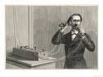

Then: Land Line Telephones Now: _____________

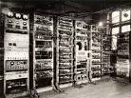

Then: Huge Computers Now: _________________

What are some other inventions that have changed drastically over the years?

What are the differences in these inventions?

What areas could have an extreme increase in inventions/discoveries in the future?

What is something that you would like to see invented/discovered in your lifetime?
Great Expectations Through Modifications:
Insulin Timeline

Insulin has 51 amino acids, 30 on one chain and 1 on the other.
The genetic code for insulin is found on the 11th chromosome.

- Insulin is discovered by Frederick Banting, Charles Best,
JJR Mcleod and James Collip.

- Bovine and Porcine insulin given to humans
(Insulin is taken from the pancreas of slaughtered animals)
(Similar to humans but different compositions)
(Initially have several side effects)

1974- Bovine and Porcine insulin now has very few impurities

1975- Synthetic Insulin is created, but due to economic reasons, it is not undertaken.

1978- Biotech company, Genetech, in San Francisco genetically manipulates plasmid of E.Coli to create insulin with exact human sequence. (genetic modification and recombinant DNA)

1980- Recombinant DNA “human insulin” is tested on 17 volunteers.

1982- FDA approves Eli Lilly’s Humulin R and Humulin N, the first genetically modified insulin.

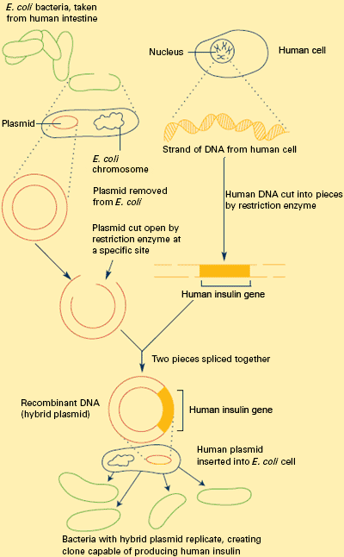
Great Expectations Through Modifications:
Teacher Background
Examples of rDNA Process for Posters

