MIDDLE SCHOOL
Biotechnology

Kitten Creation

Pre-requisite Knowledge: genes, alleles, dominant and recessive traits, genotypes, phenotypes

Goals:
- To understand that an organism’s phenotype depends on the parents’ genotypes.
- To create a kitten based on dominant and recessive genes

Objectives: Students will…
- Create a kitten based on using trait chips that match the parents’ genotypes.
- “Build” their kitten

Materials: (per group)
- Create a Kitten Sheet
- Trait Chips (cup with 8 chips, 1X-X, 1X-Y, 2T-T, 2T-t, 2t-t)
  - Use 2 different colors: One color for Sparky, and one color for Lucky
  - Sparky’s chips should include: 1X-X, 1T-T, 1T-t, 1t-t
  - Lucky’s chips should include: 1X-Y, 1T-T, 1T-t, 1t-t
- Random Craft Supplies to build a kitten. Cloth, stuffing, pipe cleaners, eyes, felt, string, thread, construction paper, glue, cat magazines, yarn….

Time Required: 45 minute class period (more time may be needed for completion of kittens)

Standards Met:
- Life Science Standards: Structure & function in living systems
- Life Science Standards: Reproduction & heredity

Procedure:
- Review the meaning of genotype and phenotype
- Inform the students that they are each going to create one of Sparky and Lucky’s kittens based on the parents’ genotypes.
- Pass a Trait Kit out to each group.
- Students will take two chips, one that matches Sparky’s genotype and one that matches Lucky’s, and put these in the cup.
- They will then shake the two chips and toss them on the table.
- The alleles that are face up are the kitten’s genotype. These will be recorded.
- The charts on the bottom of the page show the phenotype for each genotype.
- These will be recorded in the chart.

Build a Kitten - optional
- Provide the students with a variety of craft supplies.

- Using the phenotypes, the students create a kitten.
- The kitten should also be named.
- When the kittens are created, discuss why they do not all look alike.
- What should be done for the kittens with B blood?
- What should be done about the kittens that are PKD positive?

Assessment:
- Accurate completion of Create a Kitten
- Model is realistic to the phenotypes

Enrichment:
Dog Breeding Computer Game
http://pbskids.org/dragonflytv/games/dog_breeding_v37.swf

Your goal is to breed a certain type of border collie puppies by selecting parents with the right traits.

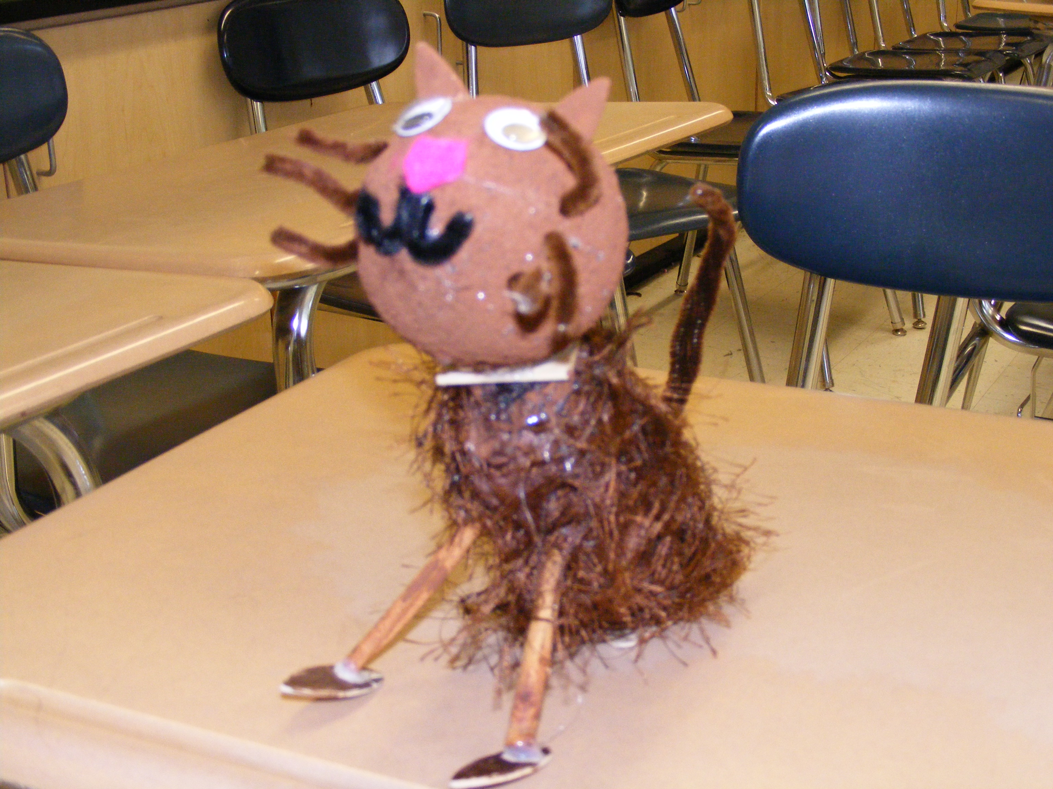
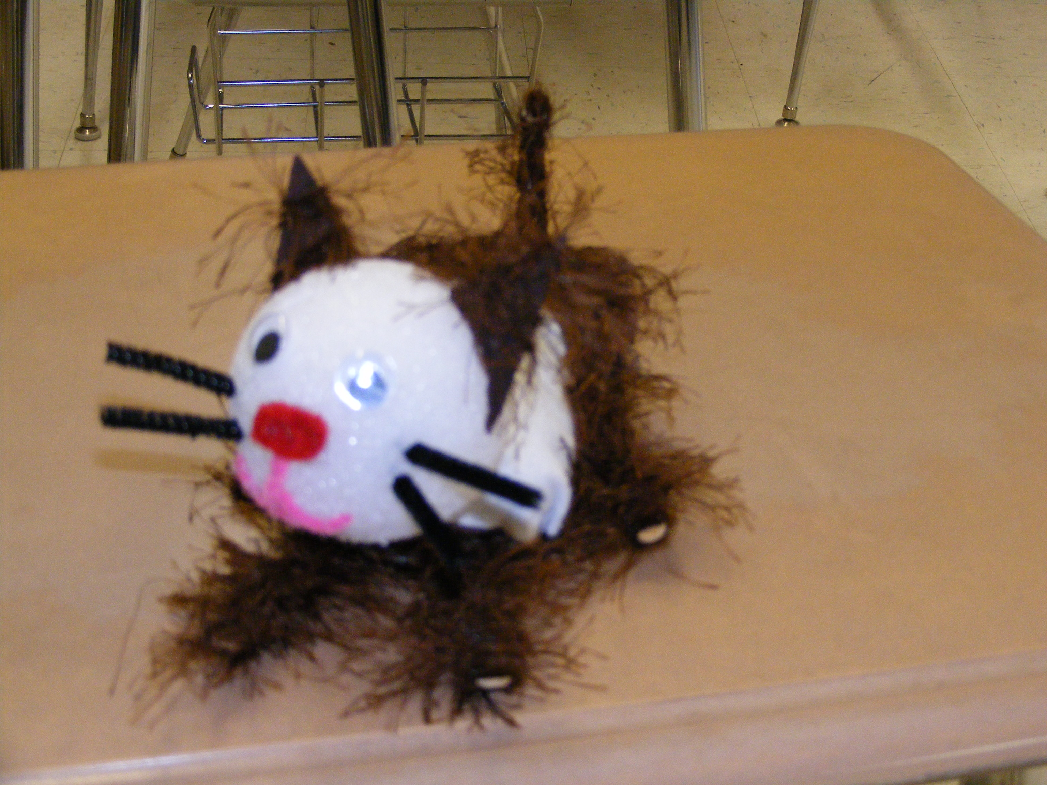

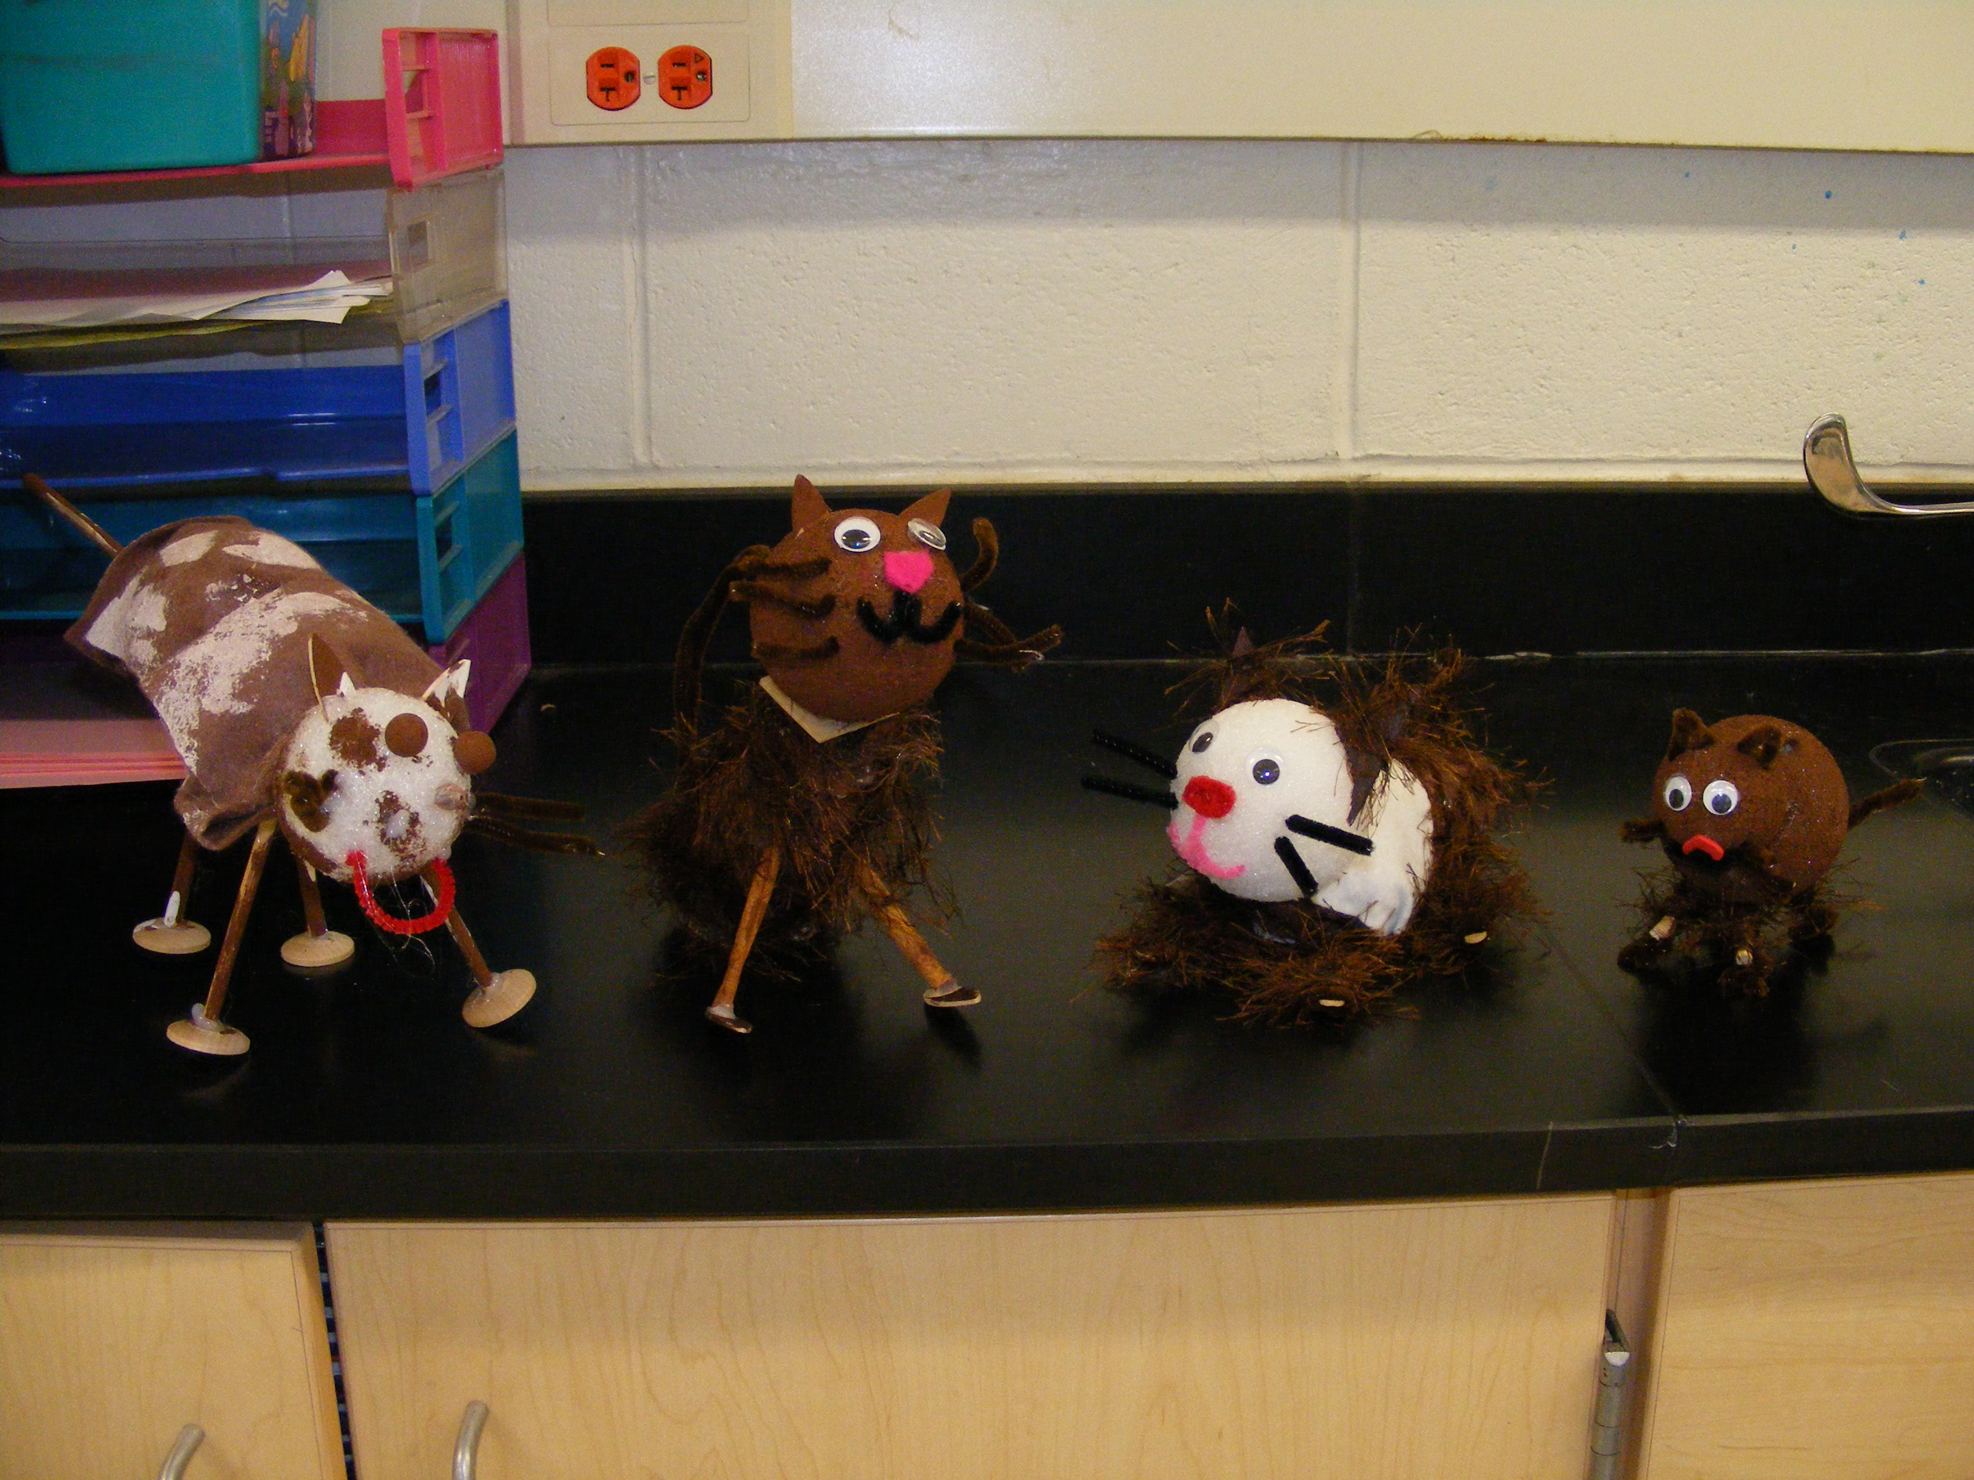
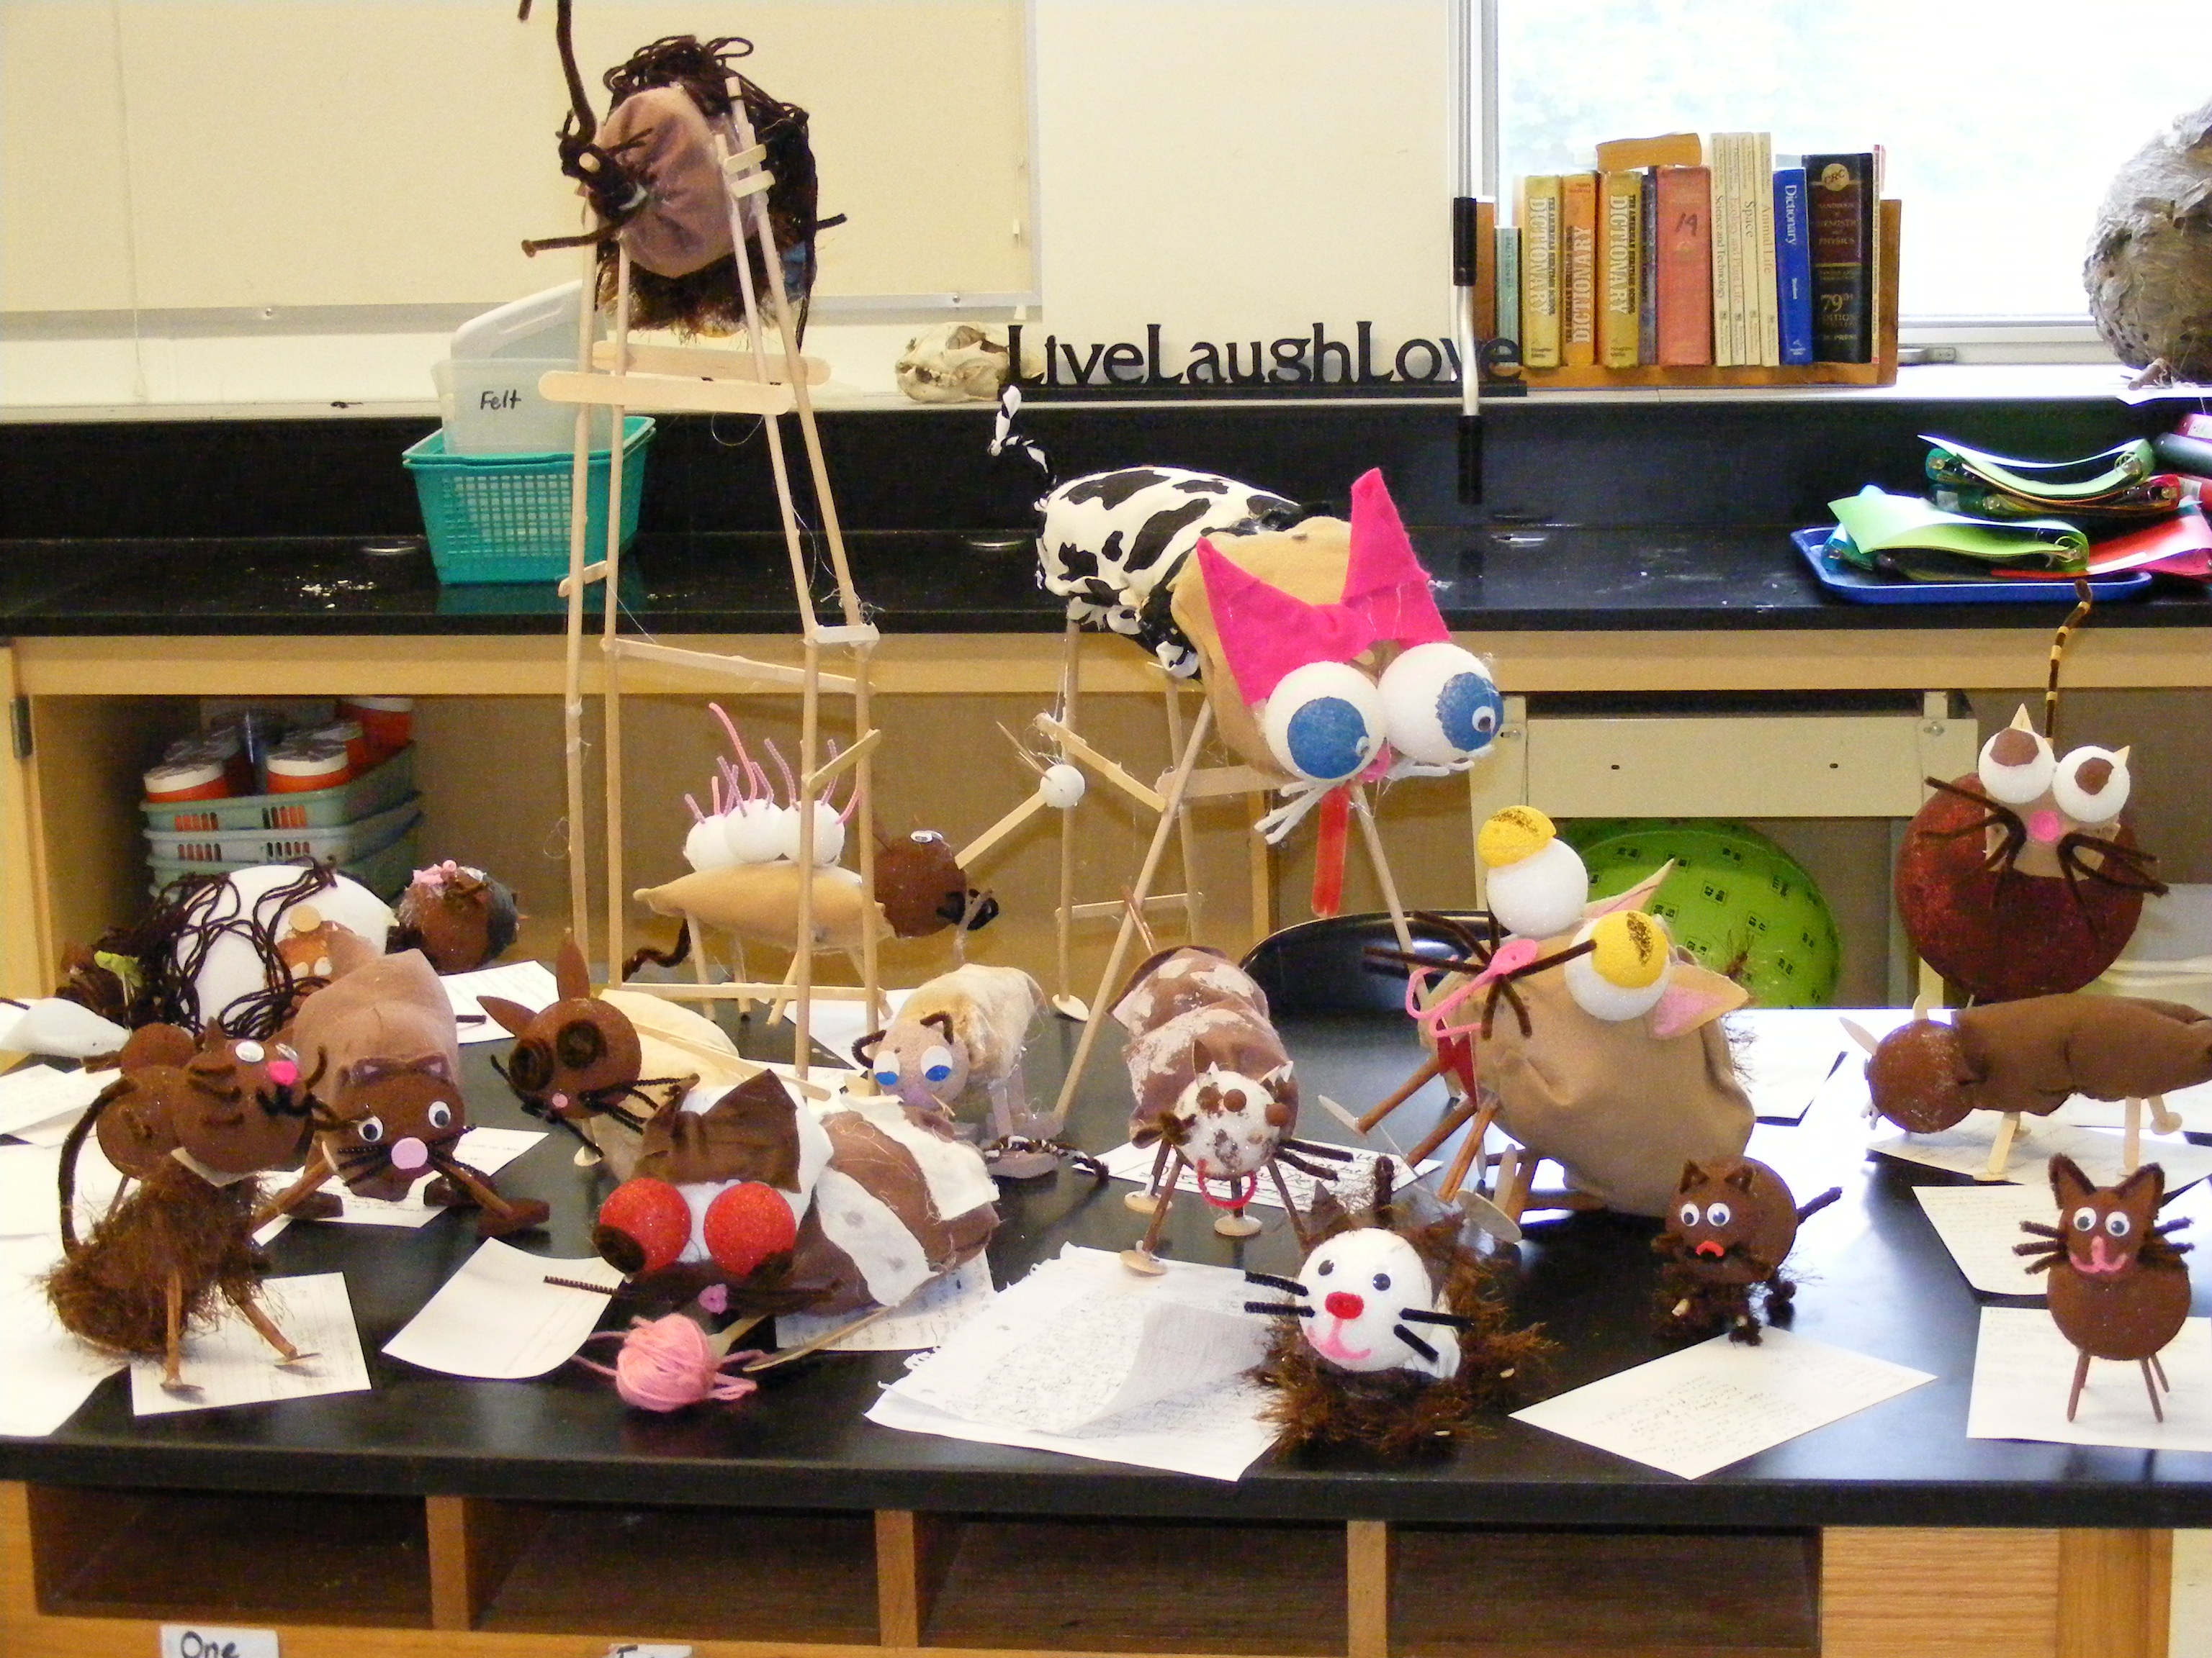
Kitten Creation – Student Sheet

For each genetic trait, find the chips that represent the parents’ genotypes.
Put these chips into the cup and shake. Toss the chips on the table.
Record the alleles that are face up in the Kitten’s genotype column.
Use the charts to write the kitten’s phenotype that matches the genotype.
Continue until all the traits are complete.
Genetic Trait | Sparky’s Genotype | Lucky’s Genotype | Kitten’s  Genotype | Kitten’s Phenotype
Sex | XX | XY
Fur Length | Tt | tt
Eye Color | TT | tt
Fur Color | TT | tt
Polydactyl | Tt | Tt
Whitespotting | Tt | tt
Ear | tt | TT
Tail | TT | Tt
PKD | tt | Tt
Blood type | Tt | tt

 | XX | XY
Sex | Female | Male

 | Phenotype | Phenotype | Phenotype
 | TT | Tt | tt
Fur Length | Short | Short | Long
Fur Color | Black | Chocolate | Cinnamon
Eye Color | Brown | Brown | Blue
Polydactyl | Normal Paw | Normal Paw | Extra Digits
White Spotting | Almost all white | 50% white | No white
Ear | Curled ear | Triangular Ear | Triangular Ear
Tail | Straight | Straight | Bent
PKD* | PKD | PKD | No PKD
Blood Type* | A | A | B

