MIDDLE SCHOOL
Biotechnology

Mapping the Males

Goal: Students will narrow down possible fathers using observation skills and accessing background knowledge. Students will also be introduced to gel electrophoresis.

Learning Objectives: Students will…
- Make observations about potential fathers based on map and biological information
- Hypothesize top biological father candidates
- Watch video about gel electrophoresis

Materials:
- Mapping the Males Regional Map
- Mapping the Males Daddy Data Sheet
- Projection system
- Access to the video weblink http://learn.genetics.utah.edu/content/labs/gel/
- Gel Electrophoresis Sequencing cards

Time Required: 45 - 60 minute class period

Standards Met:
- Science as inquiry: Abilities necessary to do scientific inquiry
- Life science: Reproduction and heredity
- Science and technology: Abilities of technological design

Procedure:
- Explain to students that Furry Friends was able to obtain a DNA gel electrophoresis fingerprint that belongs to the father of the kittens.
  - Furry Friends needs to determine which cat is the father. (Sparky is type AB blood so Furry Friends needs to make sure that the father is not B type because the combination can be harmful to kittens)
  - They have provided us with a map and would like your recommendations for potential fathers.
  - Once they have this information, they will collect samples and run DNA gel electrophoresis on those cats.
- Give each group a Mapping the Males Regional Map and Daddy Data Sheet
- Students should complete the sheet and recommend 1 cat who they believe is the strongest candidate for fatherhood.
- Once students have finished, explain that Furry Friends will complete a gel electrophoresis for each cat recommended.
- Tell students that they will complete a simulation in class tomorrow so they can experience the gel electrophoresis process.

- Today, they will watch a short video demonstrating the process
  - http://learn.genetics.utah.edu/content/labs/gel/
  - Stop the video when the picture of the man in glasses suggests that you do your own!
- If there is time, give students the cut out gel electrophoresis sequencing cards and have them put the steps in the correct order

Assessment:
- Completed Daddy Data Sheet
- Gel Electrophoresis Sequencing cards

Mapping the Males: Regional Map




Mary’s Deli Old Lady Smith’s House Café Perk

Billie XX Bowser XY Tuga XY
Spayed Age 3 Neutered Age 6 Age 17
Smoke Black & Brown Black & White Himalayan Maine Coon Abyssinian

Found
6 of the cats that were in Sparky’s shed the day of her capture
(2 were not found)
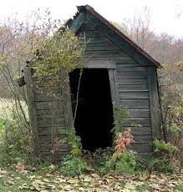

Sparky’s Shed
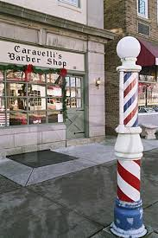
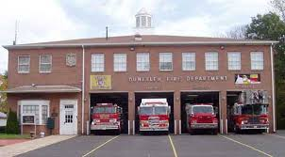
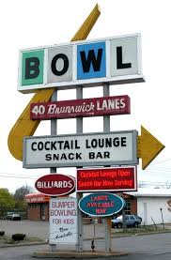

Bowl-a-Rama Pleasantville Carmen’s Firehouse Barber Shop
Carson XY Lucky XY Eloise XX
Age 9 Age 4 Age 7
Brown & White Mixed Cinnamon Orange & White American Shorthair Persian Manx


Mapping the Males: Daddy Data Sheet

Billie
- Yes
- No
2 reasons for your conclusion:
1. ______________________________
2. ______________________________

Carson
- Yes
- No
2 reasons for your conclusion:
1. ______________________________
2. ______________________________

Lucky
- Yes
- No
2 reasons for your conclusion:
1. ______________________________
2. ______________________________

Our top 3 recommendations for the father of Sparky’s kittens are:

- ___________________________
- ___________________________
- ___________________________

*Place a star by your first choice!

Bowser
- Yes
- No
2 reasons for your conclusion:
1. ______________________________
2. ______________________________

Tuga
- Yes
- No
2 reasons for your conclusion:
1. ______________________________
2. ______________________________

Eloise
- Yes
- No
2 reasons for your conclusion:
1. ______________________________
2. ______________________________

Mapping the Males: Daddy Data Sheet-Teacher Key

Billie:
Sex: XX
Spayed
Age: 3
Breed: Himalayan
Color: Smoke

Carson:
Sex: XY
Age: 9
Breed: Mixed
Color: Brown and White

Lucky:
Sex: XY
Age: 4
Breed: Persian
Color: Cinnamon

Bowser:
Sex: XY
Neutered
Age: 6
Breed: Maine Coon Cat
Color: Black and Brown

Tuga:
Sex: XY
Age: 17
Breed: Abyssinian
Color: Black and White

Eloise:
Sex: XX
Age: 7
Breed: American Short-hair
Color: Orange and White Calico

Mapping the Males: Gel Electrophoresis Sequence Cards

Add electrical current to make DNA strands move (electrophoresis) | Place DNA samples in the holes at the end of the gel using a pipette
Procure the gel, the jello-like filter | Stain the gel to see the DNA strands
Short strands move more quickly than long strands | Obtain a vial of a DNA sample
View the results | Dance a jig to celebrate your biotechnology skills

Mapping the Males: Gel Electrophoresis Sequence Cards Teacher Key

1. Obtain a vial of a DNA sample

2. Procure the gel, the jello-like filter

3. Place DNA samples in the holes at the end of the gel using a pipette

4. Add electrical current to make DNA strands move (electrophoresis)

5. Short strands move more quickly than long strands

6. Stain the gel to see the DNA strands

7. View the results

8. Dance a jig to celebrate your biotechnology skills

